**THE EFFECT OF METAL COUPLING ON THE RATE OF CORROSION**

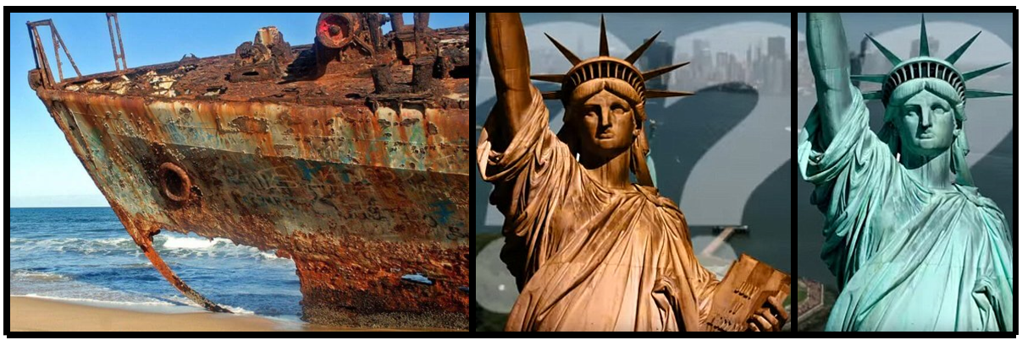

A CHEMISTRY PROJECT REPORT

Submitted By

**GIRIJA.G, CLASS** **XII**

ALWIN MEMORIAL PUBLIC SCHOOL

SELAIYUR, CHENNAI -73

## CONTENTS

## Acknowledgement

## Introduction to Corrosion

## Factors affecting Corrosion

## Corrosion in everyday life

## Rusting of Iron

## Colour change in the statue of liberty

## Rusting of Neodymium Magnets

## Tarnishing of silver

## Rusting of “THE MOON”

## Prevention of Corrosion

## Bibliography

## 

## 

## ACKNOWLEDGEMENT

I undertook this project work, as a part of my class 12th Chemistry Practicals. I would like to express my gratitude and thanks to my Chemistry teacher Mrs.Rathi and my parents for their continuous support throughout this project. And a special thanks to my sister Menaja. G for motivating me throughout this project, and to all those who contributed directly or indirectly towards the completion of this school project.

## 

## INTRODUCTION

## CORROSION:-

when metals or exposed to atmospheric conditions they react with air or water in the environment and their surfaces get coated with undesirable compounds usually with oxides this process is called corrosion.

Almost all metals except the least active metals such as gold, platinum, and palladium are attacked by the environment which is why they undergo corrosion. For example, silver tarnishes and copper develops a green coating lead and stainless steel loses its luster due to corrosion. Corrosion causes normal damage to building bridges ships and many other articles which are made of iron so that's why we define corrosion as a process of deterioration of a metal as a result of its reaction with air or water surrounding it.

|  |  |
| --- | --- |
| **METAL** | **CORROSION (names)** |
| Iron | Rusting |
| Copper | Patina |
| Silver | Tarnishing |

Chemically rust is a hydrated form of ferric oxide 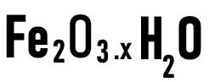 rusting of iron is generally caused by moisture carbon dioxide oxygen present in the air and it has been absorbed that rusting takes place only when the ion is in contact with moist air and does not trust in dry and or in a vacuum.

**Factors which of it corroon the main factors which affect corrosion are :-**

**1) Reactivity of the metal**

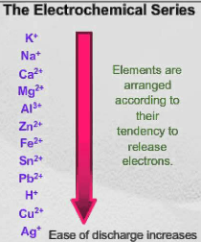The reactivity of metal depends upon the position in the electrochemical series. The more the reactivity of metal the more will be the possibility of the metal getting corroded.

**2) Presence of impurities in metals**

The impurities in metals increase the chances of corrosion. Pure metals do not corrode the impurities help in setting up voltaic cells, which increase the speed of corrosion

**3) Presence of electrolytes**

The presence of electrolytes in water also increases the rate of corrosion. for example, corrosion of iron in the sea takes place to a larger extent than in distilled water.

**4) Presence of moisture and gases in air**

Air and moisture accelerate corrosion. presence of gases such as carbon dioxide and Sulphur dioxide in the air also increases the process of corrosion. The presence of carbon dioxide in water increases rusting of iron. water containing carbon dioxide acts as an electrolyte and increases the flow of electrons from one place to another.

**5) presence of protective coatings**

when the iron surface is coated with thin layers of metals more active than ion, then the rate of corrosion is retarded, for example, coating zinc on iron prevents rusting,( so this process of preventing corrosion is also known as sacrificial protection).



**CORROSION EXAMPLES IN EVERYDAY LIFE**

1. **RUSTING OF IRON**

Iron is the 26th element with the symbol Fe in the modern periodic table of elements and has a significant role in sustaining life on planet earth. We come across several applications of iron in our daily life, such as being a crucial building block in infrastructure that provides strength, nourishes plants, and helps carry oxygen in our blood. However, the iron masses we observe around us are not in stable thermal equilibrium and tend to go under oxidation reaction to form a more stable compound. Given sufficient time, any iron mass present in the vicinity of water and oxygen is susceptible to corrosion and forms a reddish-brown iron oxide, commonly known as rust. It is formed by the reaction of iron and oxygen in the catalytic presence of water or air moisture. The general chemical composition of rust is hydrated iron (III) oxide,

however, under humid conditions, it may include iron (III) oxide-hydroxide (FeO(OH)). Several types of rust are visually different based on the circumstances under which these are formed. For instance, the most familiar form of rust is the reddish coating that forms flakes on iron and, but it can also come in other colors including yellow, brown, orange, and even green, depending on the chemical composition of the environment in which they are present. Although rust is considered as the result of an oxidation reaction, it is important to note that not all iron oxides are rust. There are many effects of corrosion in our daily life that often goes unnoticed. At home, for instance, doors, pipes, and several other iron infrastructure are damaged by corrosion over time, which affects aesthetically, and economically, and can potentially lead to accidents that have serious consequences. To address the issue, paint coatings are applied to act as a barrier between the air and the iron surface, about it we shall discuss at the end to prevent corrosion.now going on with the mechanism…

## and same mechanism happens in the case of ‘****Corrosion of the Eiffel Tower’****

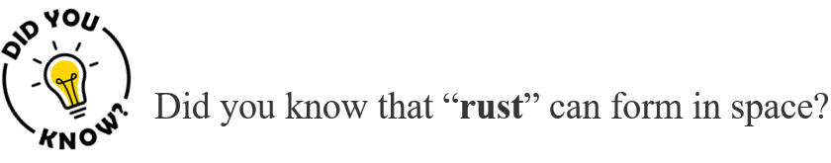

Well, in space there are ultraviolet lights that can break chemical bonds between atoms. When these atoms and ultraviolet light strike metal in space, they can produce some of the same combinations of metal and oxygen atoms found in rust. Because the **density of atoms in outer space is very low**, it takes many years for rust to form on any object. To get a sense of just how slowly things rust in space, just look at iron meteorites and chunks of metal that have fallen to earth from outer space. Before crash-landing on earth, these bits of metal floated through the solar system for millions or even billions of years but were still chunks of pure metal with little rust.

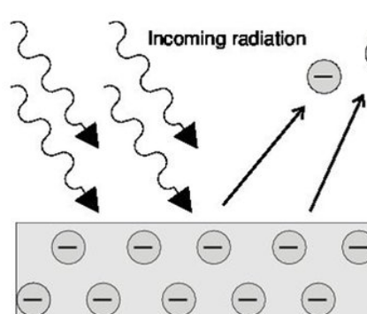

**2) CHANGE IN COLOUR OF THE STATUE OF LIBERTY**

Corrosion is often a slow change and can be observed over a great period of time. The iconic bluish-green Statue of Liberty on Liberty island of the New York Harbor, USA is a great example of such an observation. The 305-feet (93 meters) statue was built over nine years in sections of copper skin on top of an iron skeleton. When France gifted the Statue of liberty to the US as a way of commemorating the US’s fight for independence in 1886, it was actually brown in color reflecting the shiny copper surface of the skin. Over the next 30 years, though, it slowly turned to the green color you witness today. The change in appearance is a direct consequence of corrosion that took place over this period. The whole phenomenon can be understood by the series of reactions mentioned below:

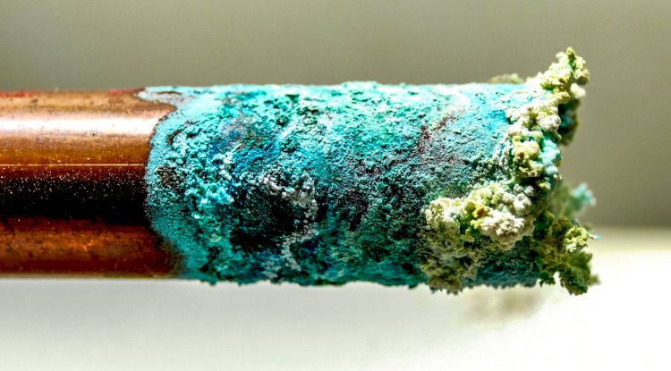

* Initially, the copper went under oxidation reaction by donating its electrons to the oxygen present in the air. This led to the formation of a reddish-pink oxide mineral known as cuprite or copper (I) oxide ()

(cuprite)(pinkish red)

* Then the copper(I) oxide continues to react with oxygen to form copper oxide (CuO), which is black in color.

(tenorite)

* Also, due to the burning of coal for energy during that time, the air contained a lot of sulfur. As a result, atmospheric sulfur trioxide, carbon dioxide, and water all reacted with the copper oxide as follow:

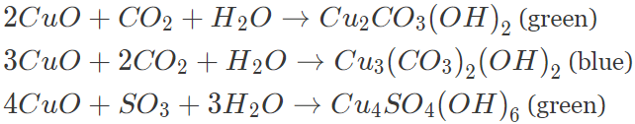

These three compounds are responsible for the characteristic blue-green patina seen on the Statue of Liberty. Fortunately, the formation of the patina creates a protective layer on the copper surface, preventing further corrosion of the underlying copper.

**3)Corrosion Neodymium Magnets**

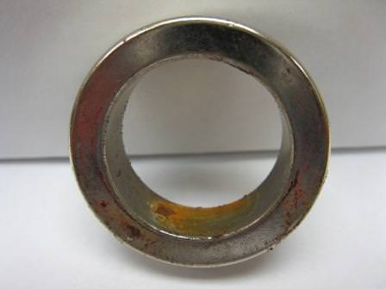

A neodymium magnet is a rare earth permanent magnet made from an alloy of iron, neodymium, and boron to form a

( )tetragonal crystalline structure. Every permanent magnet contains some form of iron as it has the most dramatic ferromagnetic properties of all elements. Because of their high iron content (64-68%), neodymium magnets are also **highly susceptible to corrosion** in damp environments, especially along with the boundary interface of a sintered magnet. This type of corrosion can cause serious deterioration including crumbling of a magnet into a powder of small magnetic particles or spalling of a surface layer. To prevent corrosion, most neodymium magnets are plated with a three-layer, nickel-copper-nickel plating. This particular plating combination performs better than zinc plating or other solutions in most applications.

**4) Tarnishing of silver**

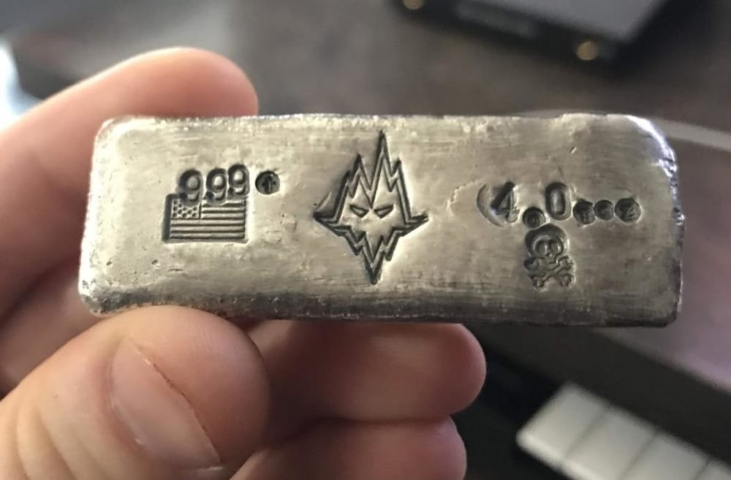

When silver utensils are exposed to air , they react with the sulfur gas present in the atmosphere which leads to the formation of **silver sulfide which is black in color**

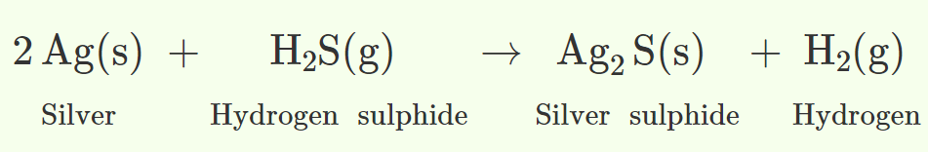

**PREVENTION**

Using a thin coat of [polish](https://en.wikipedia.org/wiki/Polishing) can prevent tarnish from forming over these metals. Tarnish can be removed by using [steel wool](https://en.wikipedia.org/wiki/Steel_wool), [sandpaper](https://en.wikipedia.org/wiki/Sandpaper), [emery paper](https://en.wikipedia.org/wiki/Emery_paper), [baking soda](https://en.wikipedia.org/wiki/Sodium_bicarbonate) or a [file](https://en.wikipedia.org/wiki/File_(tool)) to rub or polish the metal's dull surface. Fine objects (such as silverware) may have the tarnish electrochemically reversed (non-destructively) by resting the objects on a piece of aluminium foil in a pot of boiling water with a small amount of salt or baking soda,[[2]](https://en.wikipedia.org/wiki/Tarnish#cite_note-2)[[3]](https://en.wikipedia.org/wiki/Tarnish#cite_note-3) or it may be removed with a special polishing compound and a soft cloth. Gentler abrasives, like [calcium carbonate](https://en.wikipedia.org/wiki/Calcium_carbonate), are often used by museums to clean tarnished [silver](https://en.wikipedia.org/wiki/Silver) as they cannot damage or scratch the [silver](https://en.wikipedia.org/wiki/Silver) and will not leave unwanted residues

# **5)RUSTING OF MOON**

# **ISRO’s Chandrayaan-1 Reveals Rusting of Moon; Scientists Point at Earth's Atmosphere as Possible Cause**

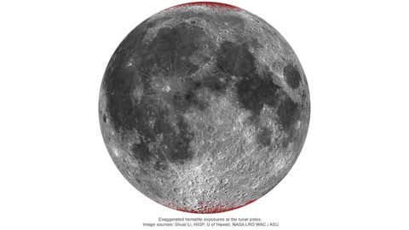

Enhanced map of ***hematite*** (red colour) on Moon using a spheric projection (nearside only).

### At a Glance

* **The formation of rust can be attributed to the presence of two key elements—water and oxygen when in contact with iron.**
* **Through magnetotail oxygen from Earth travel to the Moon.**

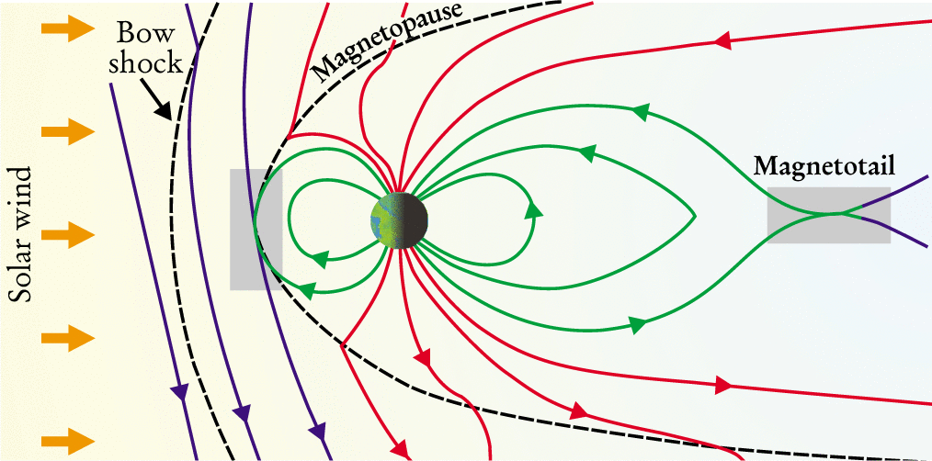

The diagram represents Earth's magnetosphere.

* **Chandrayaan-1 is credited with discovering clues of water ice on the poles of the Moon**

Data from the Indian Space Research Organisation (ISRO) has revealed that the Earth’s natural satellite Moon **might be rusting**. The new research suggests that the moon is **turning slightly red**, indicating the formation of a reddish-black mineral form of iron named **hematite** on its surface, particularly at the poles.

The formation of rust or iron oxide can be attributed to the presence of two key elements—water and oxygen—when they come in contact with iron. The lunar surface is littered with **iron-rich rocks**, which may facilitate this chemical reaction when combined with the other two elements. However, the Moon does not have any rich source of water and is devoid of oxygen in its atmosphere.

"It's very puzzling," said Shuai, who is the lead author of the study. "The Moon is a terrible environment for hematite to form in." So, what triggered such a chemical reaction over the moon? Scientists say that the main reason behind this change could be **the Earth’s atmosphere.**

Researchers noticed this phenomenon on the Moon while examining data from the **Moon Mineralogy Mapper (M3) instrument** onboard ISRO’s Chandrayaan-1 spacecraft. The data obtained from the M3 revealed the Moon's pole had a different composition as compared to its surface.

### **Role of Earth’s atmosphere**

For iron to convert into rust it needs oxidizers, which can steal electrons from the iron and thus initiate rust formation. To understand the cause, the team examined the **bombarding of hydrogen from the solar wind**. However, it had the opposite effect since hydrogen is a reducer—which ***donates electrons*** instead of taking it. Therefore, solar winds may not be the reason behind rusting on the Moon’s surface.

The airless Moon may lack an atmosphere to support the formation of oxygen, but it hosts traces of oxygen that travels from Earth to reach the lunar environment. Therefore, researchers say the Earth’s **magnetotail**—an elongated region of the planet’s **magnetosphere**—plays a significant role in this change observed over the Moon.

Back in **2007, Japan's Kaguya** orbiter helped scientists discover that oxygen from Earth's upper atmosphere can travel through magnetotail to the Moon, which is 38,500 kilometers away from the Earth. Therefore, terrestrial oxygen can reach the near side of the Moon facing the Earth and this finding means that **the oxygen from Earth** may be driving the **formation of hematite** on the lunar surface.

In addition, the magnetotail interferes with the hydrogen molecules released from the solar wind to reach the Moon’s atmosphere, which if reached may inhibit this rust formation. As per the statement from NASA, the **magnetotail blocks about 99% of the solar winds** during certain phases of the Moon's orbit—specifically in the **full Moon phase.**

As per NASA, the **Moon is slowly moving away from the Earth** for billions of years and getting an inch farther almost every year. “So, it's also possible that more oxygen hopped across this rift when the two were closer in the ancient past,” added the statement.

### **Missing clues: the presence of water on the Moon**

By now, scientists were able to decode the presence of oxygen, iron for the rust formation. But one most important element to carry this reaction was still missing i.e., water.

That’s where the data from Chandrayaan 1 again comes into play. Researchers used the data obtained from the Indian space agency’s maiden Moon mission—which remained functional till August 28, 2009. The mission is credited with discovering **clues of water ice on the poles** of the Moon along with mapping out different types of minerals formed on the lunar surface.

Researchers extensively studied the data obtained from the Moon **Mineralogy Mapper instrument** onboard spacecraft. The presence of water has been only detected on the poles of the lunar surface in the form of **frozen water**, which remains almost **entirely in shadow**.

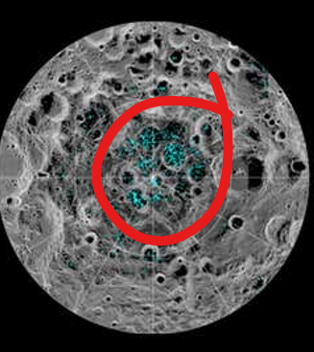

However, this research focused on the water found otherwise in the lunar surface instead of just on the poles as the hematite was discovered far from this frozen ice. Answering this puzzling question, scientists propose that **fast-moving dust particles might initiate the release of surface-borne water molecules**, thus allowing water to mix with iron.

“Heat from these impacts could increase the oxidation rate; the dust particles themselves may also be carrying water molecules, implanting them into the surface so that they mix with iron. During just the right moments–namely, when the Moon is shielded from the solar wind and oxygen is present–a rust-inducing chemical reaction could occur.” explains the statement from NASA.

**PREVENTING OF RUSTING**

The prevention of corrosion is very important and essential. it not only saves money but also helps in preventing serious accidents such as bridge collapse or failure of a key component due to corrosion. This can be prevented or retarded by the methods given below

**1)Barrier protection**

This is one of the simplest methods to prevent rusting of iron.A barrier is placed between the iron and the atmosphere. Coating surface with paint or chemicals like bisphenol.we apply oli/grease, electroplating

**2)Sacrificial protection**

Here a metal is protected from rusting by covering it with layers of metal more reactive than iron ,which prevents the loss of electrons from iron. Zinc is commonly used here, the process of covering iron with zinc is called as galvanization.

**3)Electrical protection**

Helps in protecting iron particles that are in contact with water such as underground water pipes, the article of iron is connected with more active metals like magnesium or zinc, therefore magnesium will be oxidized in the presence to iron therefore it will protect the iron from being rusted.

**4)Using antirust solutions**

Alkaline phosphate and alkaline chromates are generally used as anti-rusting solutions, H+ ions are removed from the solution, and rusting is prevented.

**BIBLIOGRAPHY**

* + <https://studiousguy.com/corrosion-examples/>
  + Mordern abc(part-1) Electrochemistry
  + <https://byjus.com/question-answer/what-is-corrosion-in-simple-words/>
  + Moon rusting

<https://www.nasa.gov/feature/jpl/the-moon-is-rusting-and-researchers-want-to-know-why>